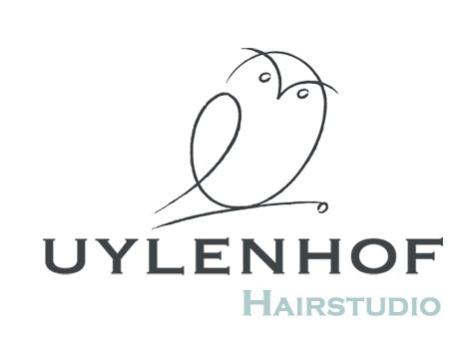
UYLENHOF HAIRSTUDIO PRIJSLIJST
Dames
Wassen, knippen, drogen |  | € 35,50
Wassen, knippen |  | € 33,50
Wassen, föhnen |  | € 30,00
Toeslag lang haar |  | € 14,-
Kleuren / folies | Vanaf | € 41,-
Studenten |  | € 29,50
Heren
Wassen, knippen, drogen |  | € 33,50
Studenten |  | € 29,50
Kinderen tot 12 jaar
Kinderen knippen |  | € 26,50
Openingstijden
zondag – maandag |  | Gesloten
Dinsdag, woensdag, vrijdag |  | 09.30 – 17.30 uur
donderdag |  | 09.30 – 20.00 uur
zaterdag |  | 09.30 – 17.30 uur

UYLENHOF HAIRSTUDIO PRICE LIST
Ladies
Wash, cut, dry |  | € 35,50
Wash, cut |  | € 33,50
Wash, blow-dry |  | € 30,00
Surcharge long hair |  | € 14,-
Dye, foils | from | € 41,-
Students |  | € 29,50
Gentlemen
Wash, cut, dry |  | € 33,50
Students |  | € 29,50
Children up to 12 years
Children’s cut |  | € 26,50
Opening Hours
Sunday – Monday |  | Closed
Tuesday - Wednesday – Friday |  | 9:30am – 5:30pm
Thursday |  | 9:30am – 8:00pm
Saturday |  | 9:30am – 5:30pm

Uylenhof Hairstudio
Tel.: +31 (0)73 – 6132404
E-mail: info@uylenhofhairstudio.nl

